## 

## Design Document

# Computer Science SOL Development

# Sponsor: CodeVA

### Department: Computer Science

#### 

#### Faculty Advisor: Dr. Budwell

## 

### Design and Implementation Team:

#### Kenneth Richardson, Benjamin Napier, Seth Vickers, Dakota Brown, Hunter Frostick

## 

## Architecture/High-Level Design

Currently, SOLs for computer science have been created for K-12 education. There is very little supporting documentation for teachers to figure out how to teach computer science SOLs. Many teachers in K-12 education are not familiar with computer science and must be educated before they can teach computer science to their students. CodeVA offers teacher-training seminars during the summer for VA public school teachers. The facilitators that lead these seminars currently use CodeVA-created presentation slides and Scratch exercises.

In regards to the teacher-training aspect of our work with CodeVA, our team will need to:

* Review the current teacher-training material (All members)
* Develop new or improve upon existing Scratch exercises to increase their rigor and effectiveness (3 members)
* Develop Python exercises to match the Scratch exercises for teachers who are more advanced or want to help their student with text-based languages (2 members)
* Create presentation slides, derived from the existing Scratch-related slides, to accompany the Python exercises (2 members)
* Improve upon the current presentation slides to make them more effective, clear, and streamlined (All members)

Additionally, CodeVA has other projects that we will be working on in the Spring. These projects are:

1. AP Computer Science Principles: create an online AP CSP course and materials for Virtual VA

* Help to create practice programs for learning and the curriculum
* Help in whatever additional needs are asked for by the project lead

1. Deep Dive Code: create a stand-alone course to introduce teachers to coding fundamentals more deeply

* Create lessons that address the tools of programming
* Create projects that correlate with lessons
* Lessons in both scratch and python

1. Dissemination Space for Curriculum: create a digital space to make curricular resources available for teachers to access and download

* Have space to collect some sort of data ( i.e. email)
* User submits and then be brought to page to download...etc ( not sent an email)

1. Teacher Knowledge Base: help in authenticating and fleshing out CodeVA’s knowledge base of computer science concepts and ideas.

* Curate resources for specific topics to explain and learn for teacher facing audience using the AP CS Principles course book

## Detailed Design

* Swim Lane Diagram

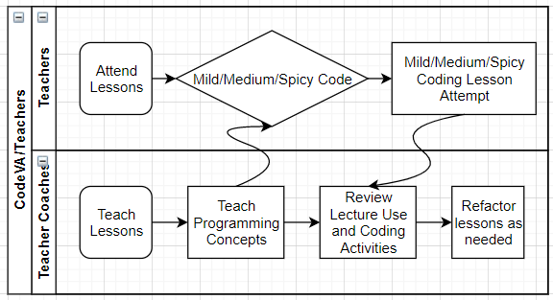

* *Presentation Layer Designs*
  + Storyboards Presentation: <https://docs.google.com/presentation/d/1oeYGBxSMSNd4qKpi5R6VKQN6WoicnEvK3boiZ8lMYGQ/edit?usp=sharing>
* Use Case Diagram  
  